Spring Data JPA with Spring Boot, Hibernate
Name: NALLANI LOKAKALYAN
Registered Mail: 2300030853cseh1@gmail.com
Hands on 1:
Spring Data JPA - Quick Example:
Application.properties:
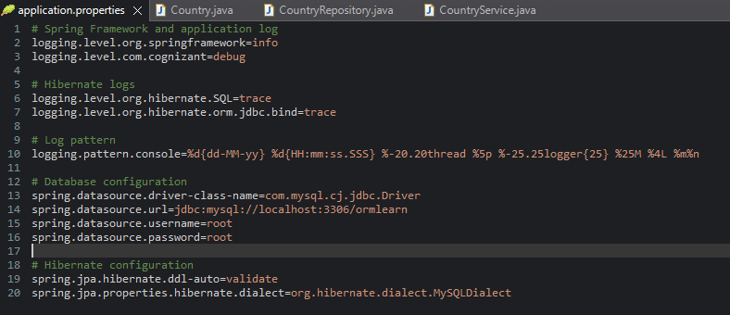
Country.java:
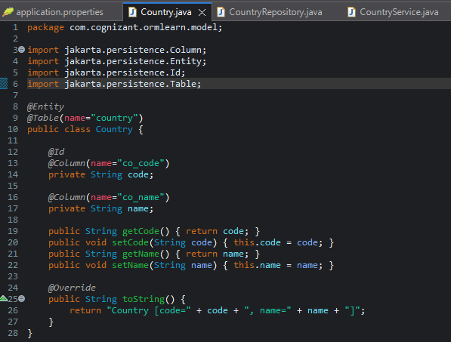
CountryRepository.java:
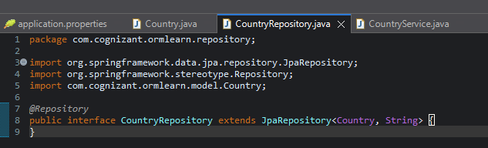
CountryService.java:
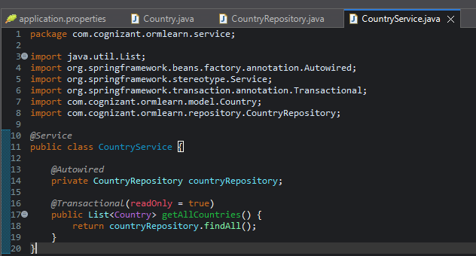

Output:
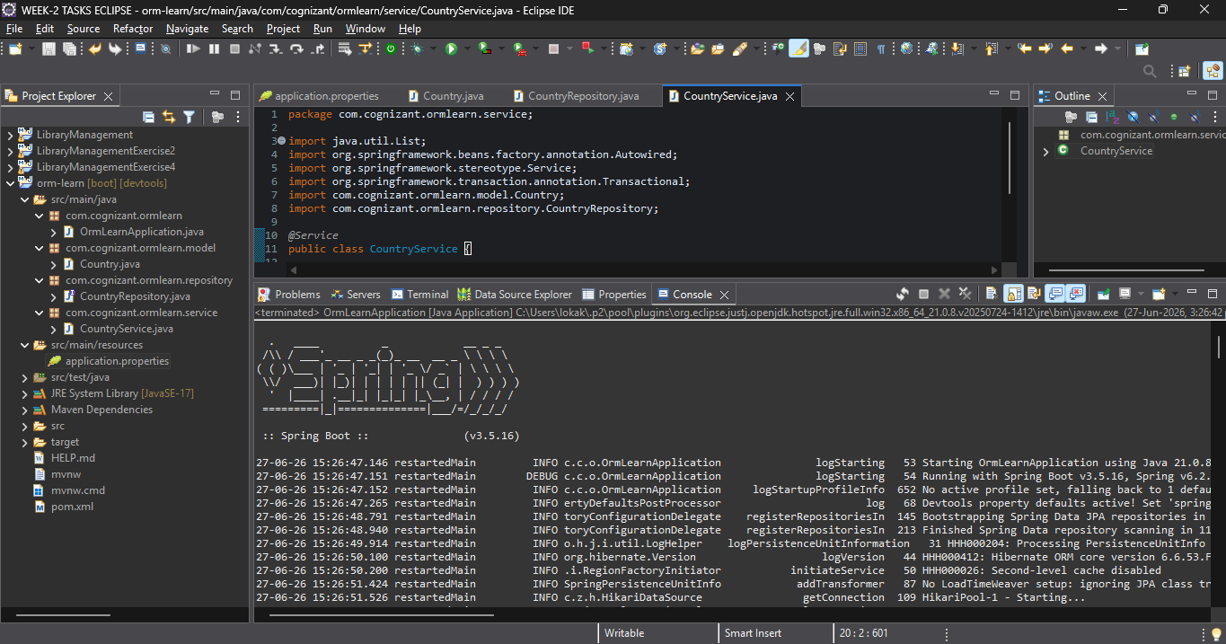
Hands on 4
Difference between JPA, Hibernate and Spring Data JPA
OrmlearnApplication.java:
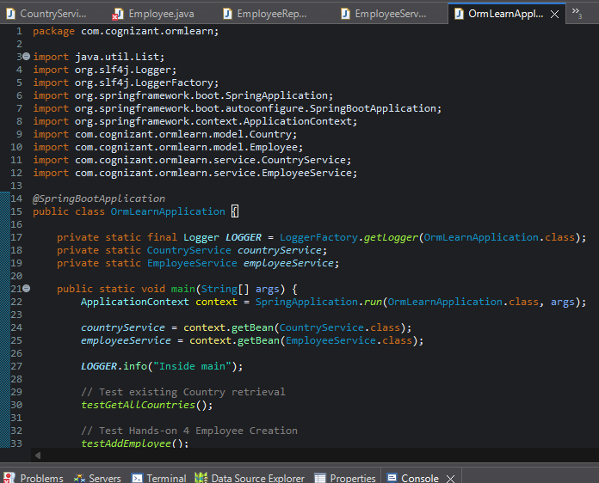
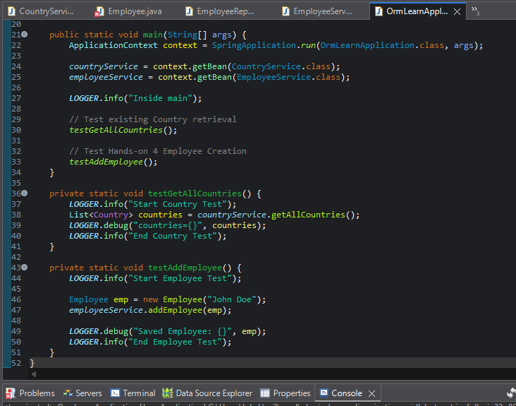
CountryService.java:
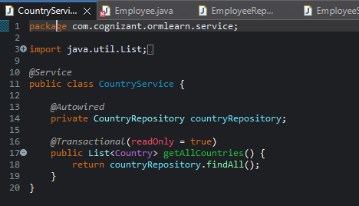
Employee.java:
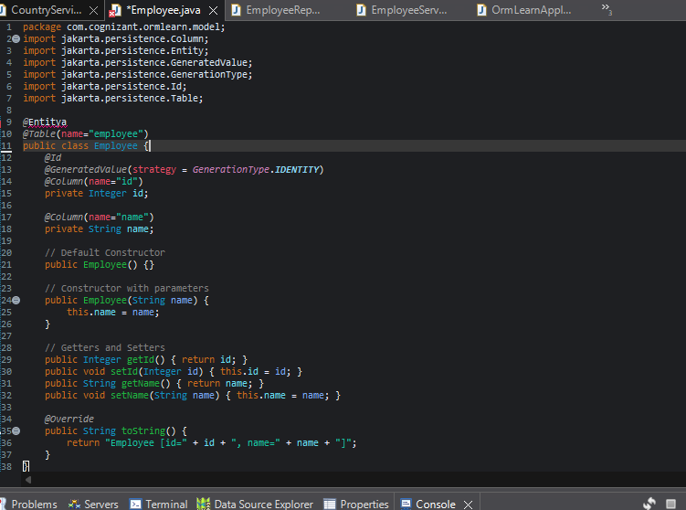
EmployeeRepository.java:
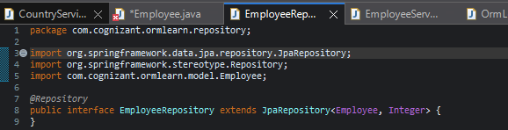
EmployeeService.java:
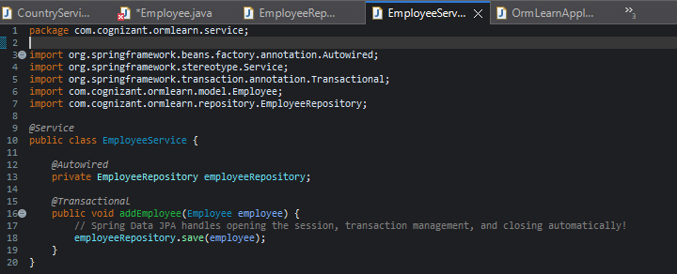

Output:
